**4+1 View Model for online Book Store**

1. **Logical View:**
2. **Class Diagram:**

*Diagram in page*

1. **State Machine Diagram**

*Diagram in page*

1. **Process View:**
2. **Sequence Diagram:**

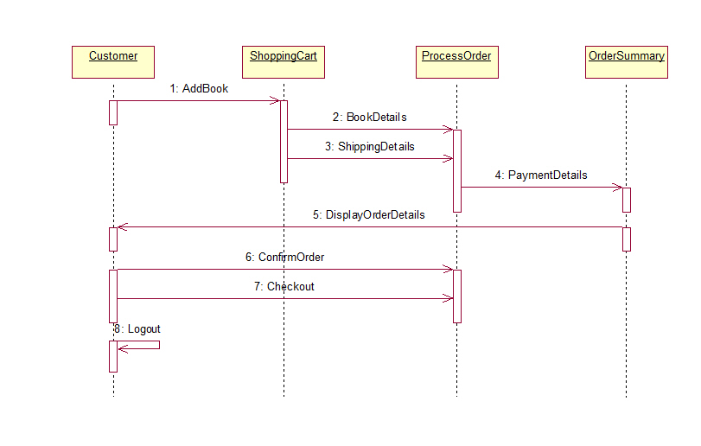

1. **Communication Diagram:**

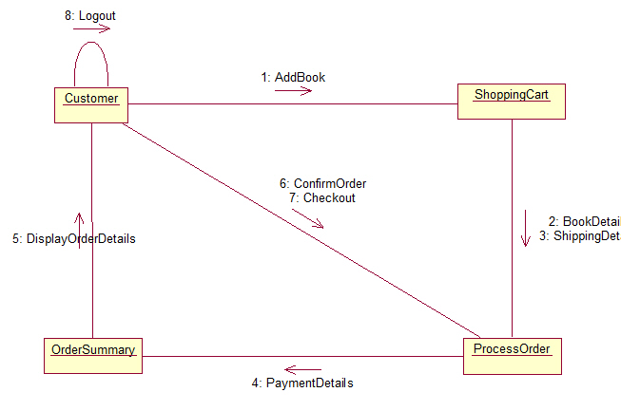

1. 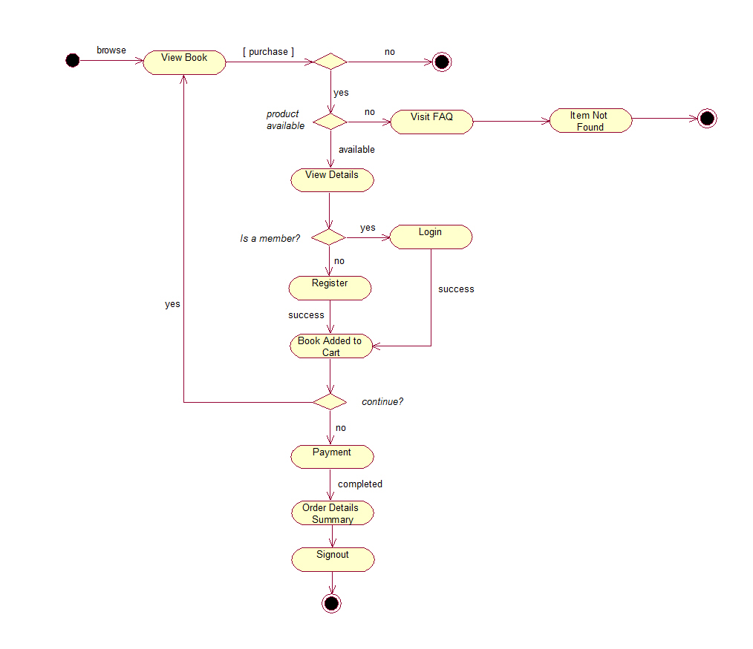**Activity Diagram:**
2. **Development View:**
3. 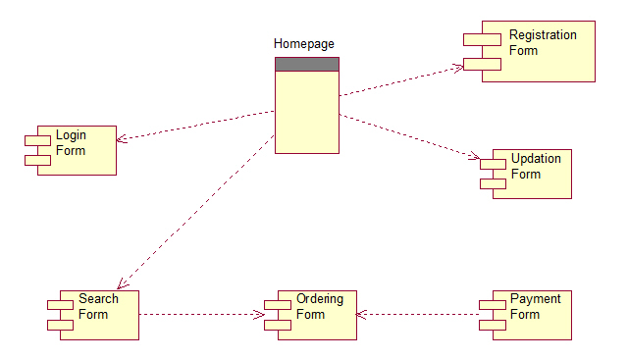**Component Diagram**
4. **Physical View:**
5. **Deployment Diagram:**

